**AWS OVERVIEW**

Q.1 List out the types of instance base on the pricing model and write a brief about your understanding about it.

Based on pricing model, instances can be of 5 types:

**On-Demand Instances:**

This model is flexible as it allows us to increase or decrease the capacity as per our need. There is no long term commitment and capacity is tracked by the second(minimum of minute).

**Reserved Instances:**

It allows us to commit to use a specific instance type in a specific region for a 1- or 3-year term. In exchange for this commitment, AWS offers significant discounts (up to 75%) compared to On-Demand prices.

**Spot Instances:**

It allows us to bid for unused EC2 capacity at a potentially lower price than On-Demand instances. The price for Spot Instances fluctuates based on supply and demand. AWS can terminate your Spot Instances if the demand for capacity increases or the price exceeds your bid.

Spot instances can be terminated by the cloud provider with very little notice (usually a couple of minutes).

**Dedicated instances:**

Dedicated Hosts are physical servers dedicated to your use. This model gives you more control over your hardware and is often used for compliance requirements or licensing that mandates physical isolation.

**Savings Plans:**

AWS Savings Plans offer a flexible pricing model that provides significant savings over On-Demand pricing in exchange for committing to a consistent amount of usage (measured in $/hr) for a 1- or 3-year term.

Unlike Reserved Instances, Savings Plans are not tied to specific instance types or regions, allowing you to use the savings across different instance families, operating systems, or regions.

My understanding from different types of EC2 instances in terms of pricing is AWS provide a huge range of machine choices with different pricing principles,to cater different user needs compromising on one or multiple factors like risk,scalability,latency,reliability.

Q2. Host a static website in S3.

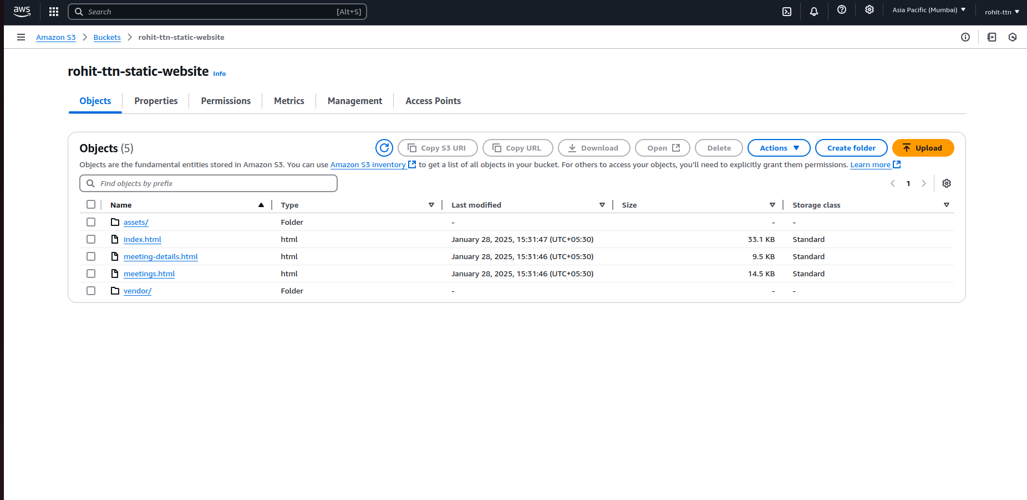

website-link:<http://rohit-ttn-static-website.s3-website.ap-south-1.amazonaws.com/>



*note-Above static website is downloaded from web.*

Q.3 Launch an Ubuntu EC2 instance on AWS, with 10GB root volume, and SSH from your local machine using the private key.

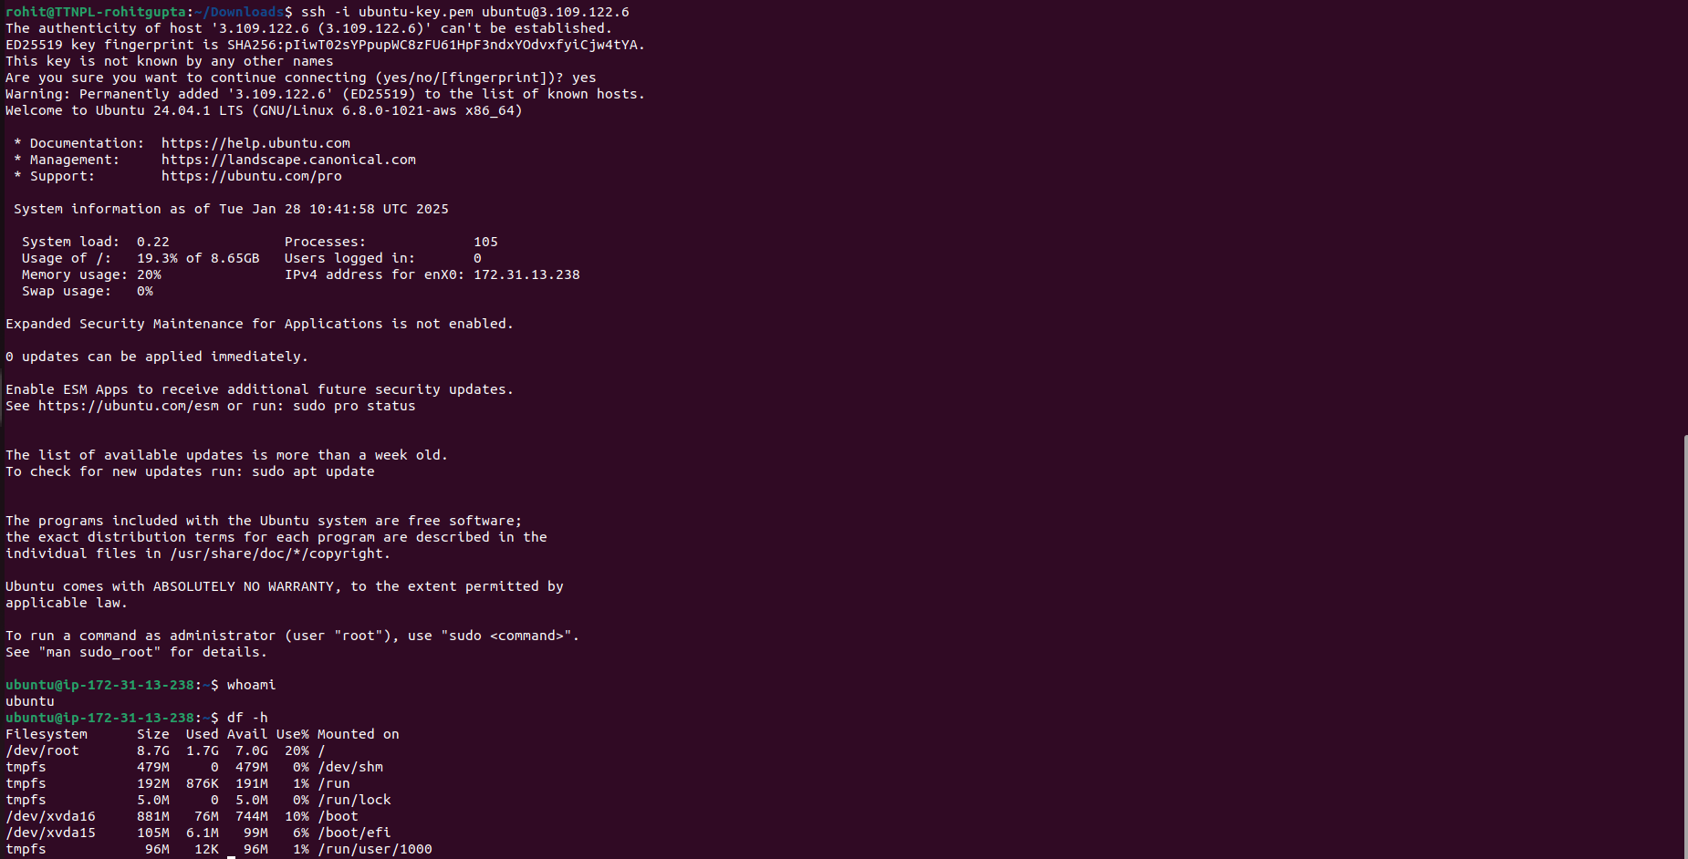

Q.4 Install nginx package in the above server and access this page from your local browser using a domain name instead of IP address of the server.

Installing nginx and running it.

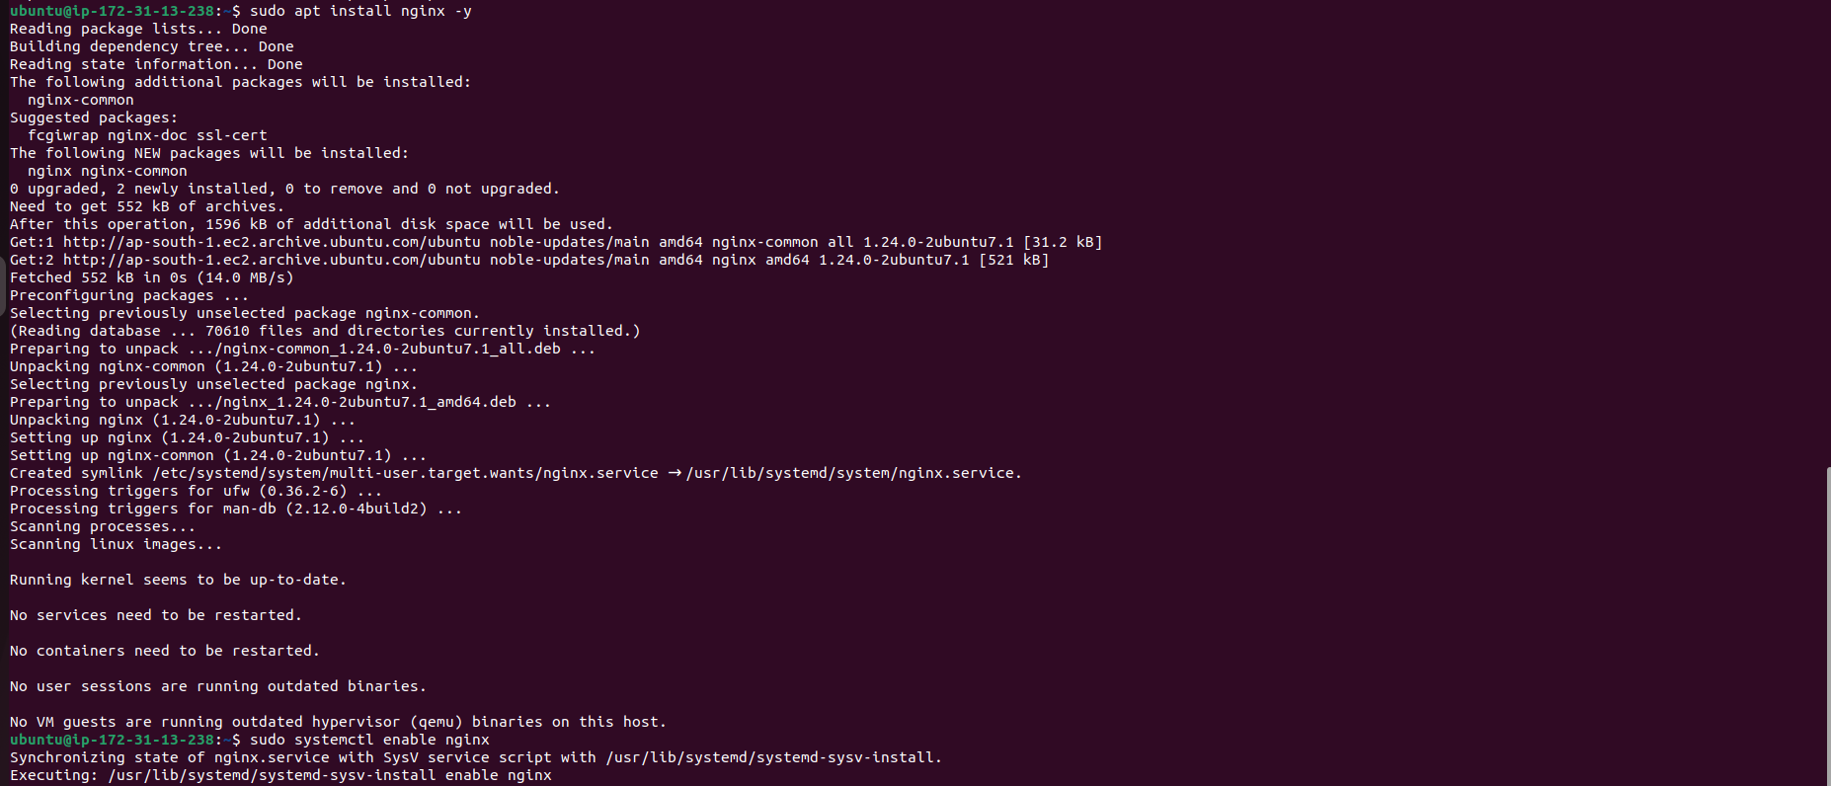

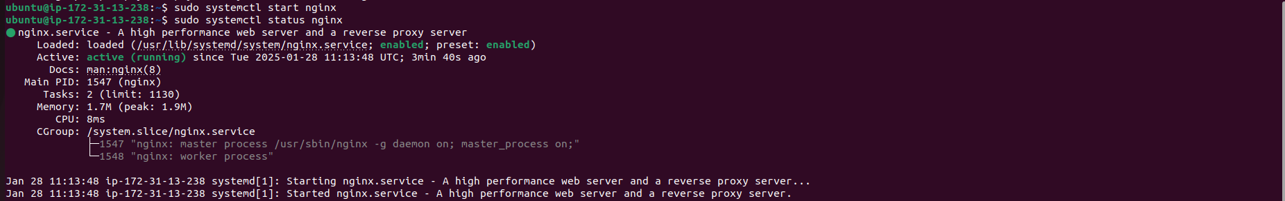

Adding http requests in inbound rules.

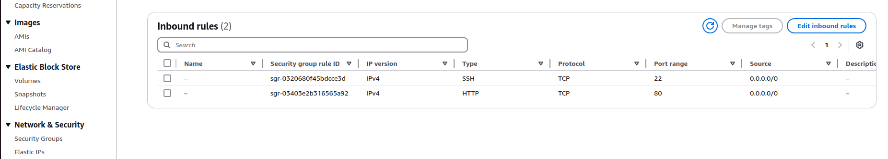

Accessing this page using domain name

